**Assignment on EE256: Rooftop Solar Plant Design and Analysis**

This assignment utilizes the JRC Photovoltaic Geographical Information System (PVGIS) design tool (https://re.jrc.ec.europa.eu/pvg_tools/en/#PVP) to design and analyse a rooftop solar photovoltaic (PV) system for a hostel building. The tasks are structured to develop skills in solar plant design, resource assessment, energy output analysis, and financial evaluation.

**Task 1: Characterizing the Building and Rooftop Solar Plant Design [30 marks]**

**Objective**: Design a rooftop solar PV system for a hostel building based on site-specific data and engineering principles.

1. Site Assessment:

* Use Google Maps, Google Earth, or equivalent software to identify the hostel building assigned to you.
* Determine the approximately south-facing roof area (in square meters) suitable for solar panel installation. Account for obstructions and shading from nearby structures or trees.
* Provide a screenshot or diagram of the roof with annotations indicating usable area and any excluded sections.

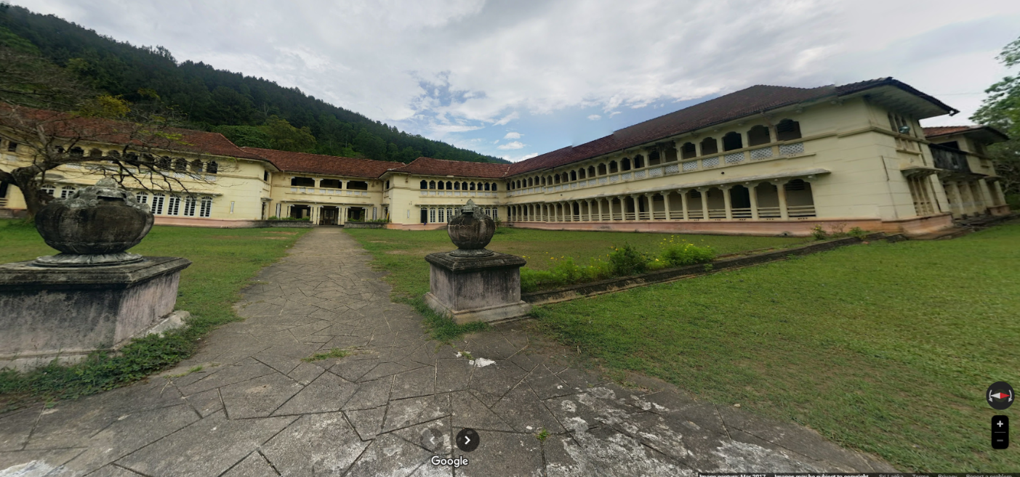

Figure 1 - Marcus Fernando Hall

For this project, the Marcus Fernando Hall was selected as the reference hostel building for the solar panel installation study. Three south-facing roof sections were identified for approximate calculations. As the **building is taller than the surrounding trees and nearby structures, it was assumed that these areas would remain** **unobstructed and free from shading**.

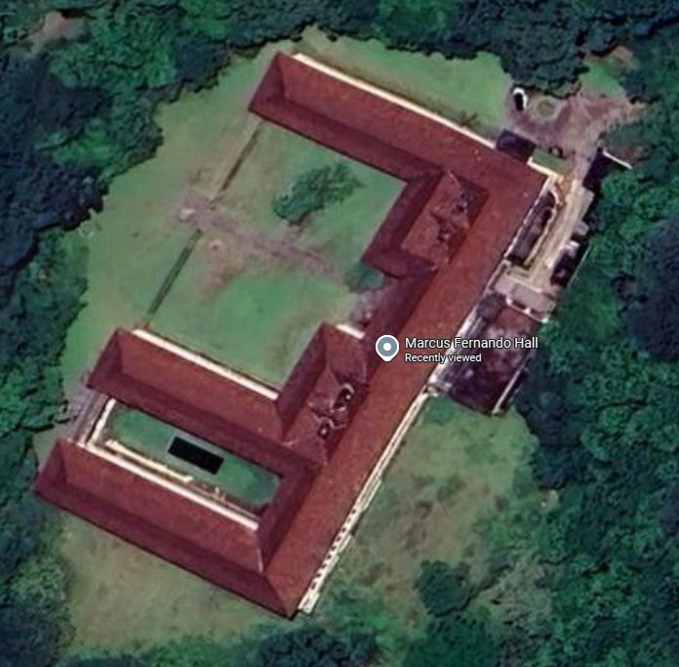

53m

40m

35m

4m

4m

4m

Figure 2 - approximately south-facing roof dimensions

Total approximately south-facing roof area = [(4x53) +(4x40) +(4x35)] m2

= (212 + 160 + 140) m2

= 512m2

1. Solar Plant Design:

* Using design techniques from the industrial lecture (e.g., panel sizing, spacing to avoid shading, and system capacity optimization), propose a suitable PV system.
* Select appropriate solar panels (specify type, efficiency, and wattage) and inverters (specify type and capacity) based on industry standards.
* Calculate the total system capacity (in kW) and the number of panels required, considering the usable roof area and panel dimensions.

Solar modules with dimensions of **2.278 m × 1.134 m** are available from Jinko Solar. For the design and calculations in this study, the **Jinko Solar model JKM595N-72HL4** was used.

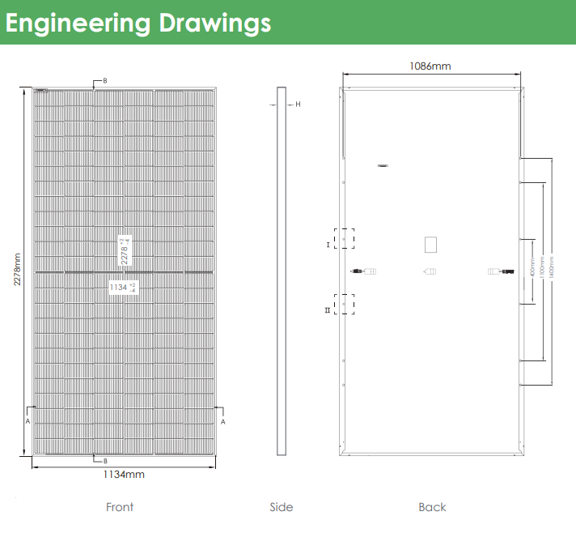

Figure 3 – Engineering drawing of the solar panel

As the column-wise dimension of the roof was approximately 4 m, only three rows of solar panels could be accommodated on each roof. The total number of panels that can be installed on each roof section is summarized below.

Roof 1 (4 x 53)

Total no. of solar panels = 3 x 22

= 66

Roof 2 (4 x 40)

Total no. of solar panels = 3 x 16

= 48

Roof 3 (4 x 35)

Total no. of solar panels = 3 x 14

= 42

Figure 4 – Solar panel distribution on roofs

|  |  |
| --- | --- |
| Maximum Power (Pmax) | 595Wp |
| Maximum Power Voltage (Vmp) | 42.81V |
| Maximum Power Current (Imp) | 13.90A |
| Open-circuit Voltage (Voc) | 51.41V |
| Short-circuit Current (Isc) | 14.71A |
| Module Efficiency STC (%) | 23.03% |

Table 1 - JKM595N-72HL4 specifications

Total no. of solar panels = 66+48+42

= 156

Total peak power production = 156 x 595W

= 92.820 kW

Since the maximum power generated by the solar panels is estimated at 92.82 kW, two inverters were selected for the system: a **60 kW Sungrow SG60CX** and a **40 kW Huawei SUN2000-40KTL-M3**.

Table 2 - Huawei SUN2000-40KTL-M3 specifications

|  |  |
| --- | --- |
| Max. power | 40kW |
| Max. DC Voltage | 1100 V |
| Rated DC Voltage | 600 V |
| Min. DC Voltage to Start Feed In | 200 V |
| Max. DC Current | 104 A |
| DC Inputs | 8 |

Table 3 - Sungrow SG60CX specifications

|  |  |
| --- | --- |
| Max Power | 60kW |
| Max. DC Voltage | 1000 V |
| Rated DC Voltage | 710 V |
| Min. DC Voltage to Start Feed In | 200 V |
| Max. DC Current | 156 A |
| DC Inputs | 6 |

**Total system capacity** = 92.820 kW

**Number of panels required** = 156

1. Electrical Layout Diagram:

* Draw a single-line electrical diagram showing:
  + Arrangement of PV modules (series/parallel connections).
  + Inverter placement and connection to the grid.
  + Metering and safety devices (e.g., circuit breakers, disconnect switches).
* Use software like AutoCAD, SketchUp, or hand-drawn diagrams (scanned and uploaded).

Based on the design calculations, **66 panels from the first roof (≈ 39.27 kW) were allocated to the 40 kW inverter**, while the **remaining 90 panels from the second and third roofs (≈ 53.55 kW) were connected to the 60 kW inverter.**

String design for roof 1

6 strings with 11 panels on each

This way,

Max. input voltage = 42.81V x 11

= 470.91V

Max. input current = 13.9A x 6

= 83.4A

Since the calculated maximum input voltage (470.91 V) is lower than the maximum rated input voltage of the Huawei SUN2000-40KTL-M3, and the calculated maximum input current (83.4 A) is within the inverter’s rated input current limit, this string design is considered suitable.

String design for roof 2 and 3

6 strings with 15 panels on each

This way,

Max. input voltage = 42.81V x 15

= 642.15V

Max. input current = 13.9A x 6

= 83.4A

Since the calculated maximum input voltage (642.15 V) is lower than the maximum rated input voltage of the Sungrow SG60CX, and the calculated maximum input current (83.4 A) is within the inverter’s rated input current limit, this string design is considered suitable.

1. Daily Energy Demand Estimation:

* Estimate the hostel’s daily electrical demand (in kWh) for weekdays and weekends.
* Divide the day into logical time periods (e.g., morning: 6 AM–12 PM, afternoon: 12 PM–6 PM, evening: 6 PM–12 AM, night: 12 AM–6 AM).
* Provide a table summarizing demand for each time period, considering typical hostel activities.
* Justify assumptions based on typical hostel occupancy and equipment usage.

Table 4 - daily electrical demand for rooms (in kWh) for weekdays

|  |  |  |  |
| --- | --- | --- | --- |
| **Weekday** | **Appliances** | **Turn on time** | **kWhr** |
| **Morning** | Iron 1000W | 5min | 0.0833 |
| Phone*3 - 60W | 1hr | 0.06 |
| Lights*2 - 24W | 1hr | 0.024 |
| **Afternoon** | Lights*2 - 24W | 1hr | 0.024 |
| Kettle -1000W | 10min | 0.166 |
| Laptop*3 -300W | 1.5hr | 0.45 |
| Phone * 3 - 60W | 1hr | 0.06 |
| **Evening** | Lights*2 - 24W | 6hr | 0.144 |
| Laptop*3 -300W | 3hr | 0.9 |
| Phone * 3 - 60W | 1hr | 0.06 |
| Kettle -1000W | 10min | 0.166 |
| **Night** | Lights*2 - 24W | 2hr | 0.048 |
| Laptop*3 -300W | 1hr | 0.3 |
| Phone * 3 - 60W | 1hr | 0.06 |
| **Total demand for 90 rooms** |  |  | **229.077** |

Table 5 - daily electrical demand for rooms (in kWh) for weekends

|  |  |  |  |
| --- | --- | --- | --- |
| **Weekend** | **Appliances** | **Turn on time** | **kWhr** |
| **Morning** | iron 1000W | 10min | 0.166 |
| phone * 3 - 60W | 0.5hr | 0.03 |
| lights*2 - 24W | 0.5hr | 0.012 |
| **Afternoon** | lights*2 - 20W | 0.5hr | 0.01 |
| kettle -1000W | 5min | 0.08 |
| laptop*3 -300W | 3hr | 0.9 |
| phone * 3 - 60W | 0.5hr | 0.03 |
| **Evening** | lights*2 - 24W | 6hr | 0.144 |
| laptop*3 -300W | 1hr | 0.3 |
| phone * 3 - 60W | 0.5hr | 0.03 |
| kettle -1000W | 10min | 0.166 |
| **Night** | lights*2 - 24W | 2hr | 0.048 |
| laptop*3 -300W | 1hr | 0.3 |
| phone * 3 - 60W | 0.5hr | 0.03 |
| **Total demand for 90 rooms** |  |  | **202.14** |

Total demand for a week = (202.14kWh x 2) + (229.077kWh x 5)

= 1,549.665 kWh

Table 6 - daily electrical demand for other appliances (in kWh) for weekdays and weekends

|  |  |  |  |
| --- | --- | --- | --- |
| **Weekdays** | **Appliances** | **Turn on time** | **kWhr** |
| **Morning** | canteen refrigerators*2 - 1000W | 6hr | 6 |
| canteen boiler 2000W | 5hr | 10 |
| Other lights*50 - 600W | 1hr | 0.6 |
| **Afternoon** | canteen refrigerators*2 - 1000W | 6hr | 6 |
| canteen boiler 2000W | 5hr | 10 |
| **Evening** | canteen refrigerators*2 - 1000W | 6hr | 6 |
| canteen boiler 2000W | 4hr | 8 |
| Other lights*50 - 600W | 6hr | 3.6 |
| **Night** | canteen refrigerators*2 - 1000W | 6hr | 6 |
| Other lights*20 - 240W | 6hr | 1.44 |
| **Total demand** |  |  | 57.64 |

Total demand for a week = 57.64kWh x 7

= 403.48 kWh

Therefore,

Total demand from both = 403.48kWh + 1,549.665 kWh

Per week = 1953.145kWh

Total demand annually = 1953.145kWh x 52

= 101.56mWh